**Suffolk Horse Society Annual Awards Dinner Auction**

**The Awards Dinner Auction is open to all. Bids can be made in advance or it will be possible to take bids during the auction on the night. Please contact the office to register and you will be assigned a Council Member and a mobile ‘phone number. During the auction you can then liaise with your telephone contact to place 'live’' bids.**

There are a number of interesting and unique items offered for the auction this year and a selection are included here. However, a full list of items will be available on the website nearer to the date of the dinner and available at the dinner on 30th November. Bids in advance will be welcome.

Please call the office to (email or ‘phone) to leave your bid; or to book your telephone link on the night. Advance bids will be passed to the auctioneer on the evening and you will be notified promptly if you are successful in securing the item.

*\*\*Please note that postage is payable if delivery is required. Auction details on all items are correct at the time of going to press. Please check the website for updates and amendments*.

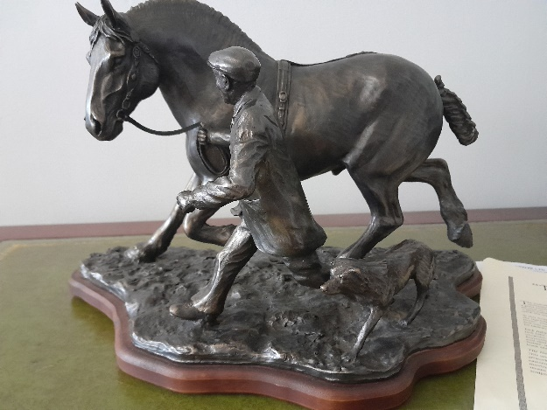**A Limited Addition Bronze – The Morning of the Show by Mary Laing. (12/500)**

A beautiful bronze sculpture measuring approximately 11 inches high. Mary Laing has captured the essence of the Suffolk horse perfectly in this tableau.

The bronze is of the remarkable Jack Ruby, known as the Master of the Heavy Horse, with his faithful collie dog at his heel.

Provenance included.

Donated by Lesley Miller.

*Reserve £1000*

**Signed Limited Edition Print by Julie Whalesby**

Julie Whalesby is a self-taught, watercolour artist who has recently had the opportunity to retire and concentrate on her artwork for the first time since her school days 30 years ago.

She creates bespoke, commissioned pet portraits for the people of Suffolk, the U.K. and also overseas. Along with her workshops and art displays she has found a new journey that is both rewarding and fun.

Originally from Kent, she moved to Suffolk with her family and has never looked back. She has recently had the chance to learn about the incredible Suffolk Punch horse. She is proud to have painted this picture and is very pleased to support the Society with this signed print as a fundraiser.

<https://www.facebook.com/JulesWhalesbyArt>

<https://www.instagram.com/JulesWhalesbyArt>

**A three night stay in a shepherd’s hut.**

Tucked away in the Suffolk countryside and hidden in an

orchard. Enjoy a peaceful, away-from-it-all, romantic

break. Equipped to a high standard, with full size shower, Wi-Fi and TV. Less than half an hour’s drive from

Southwold and the Suffolk Heritage Coast.

*Kindly donated by Gail & Michael Sprake.*

*Guide Price: £250*

**Hand- crafted Sculpture of a Suffolk Horse**

By a well-known local artist and sculptress, Mary Keeble.

*Kindly donated by Mary Keeble.*

***Carriage drive for two.***

Enjoy a leisurely drive through the beautiful countryside in Suffolk and Norfolk. Coffee on arrival and meet the horses.

Lunch is in a local pub halfway round, then continue the drive through the Waveney Valley, past a lovely historic mill and back to the farm for afternoon tea.

*Kindly donated by Mrs Jayne Groom.*

*Guide Price: £100*

**Photo Shoot**

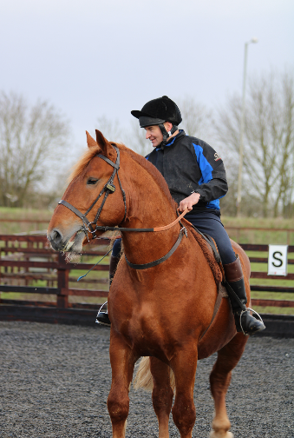Tegan-Amy Mould is Head girl at Thorpeley Stud and a keen heavy horse enthusiast as well as being an amateur photographer who takes photos to a professional standard.

Tegan is offering a half day photo shoot at your yard. You will receive all the best pictures edited and ready to download for your own personal album or social media accounts. This shoot can incorporate family, friends, pets and of course, your horse/horses as the main models! The photos can be completely your choice, from ridden action shots to still decorated harnesses pics and even them in their natural environment.

An ideal gift for Christmas or for sentimental purposes. A mutual time and venue to suit both parties can be arranged.

*Kindly donated by Tegan-Amy Mould*

**Plus many other auction prizes, which will be advertised on the website and available at the dinner.**