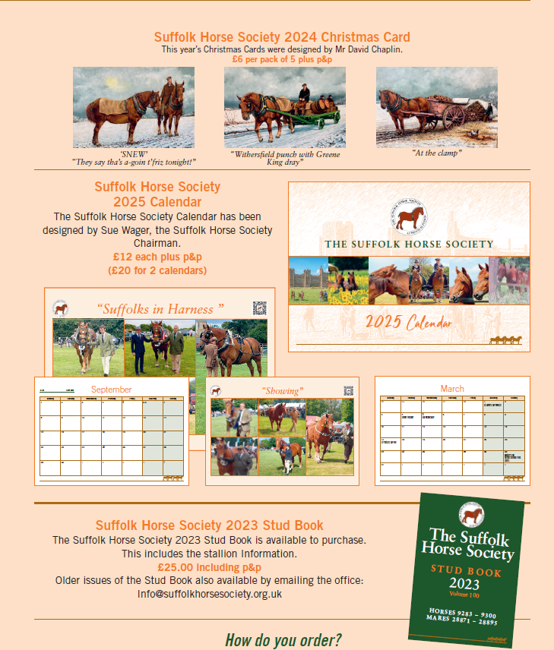

Email - [info@suffolkhorsesociety.org.uk](mailto:info@suffolkhorsesociety.org.uk) or telephone the office - 01394 380643 with your order.

Please add postage to the order amount.

Cards £2.50 for up to two packs, £3 for 3-6 packs. If the order includes a calendar postage is £3.75.

A single calendar is £2.50. 2-5 calendars are £4.00.

Payment can be made cheque (Suffolk Horse Society) or by card over the telephone.